GEK1509

By: Jin Zhe

NUS

INTRODUCTION TO THE NANOWORLD

**Disclaimer:** While conscientious effort was made to ensure the accuracy and correctness of this document’s contents, errata are inevitable. Please use this resource at your own discretion.

|  |  |  |  |  |  |  |  |  |
| --- | --- | --- | --- | --- | --- | --- | --- | --- |
| Prefix | Symbol | 1000m | 10n | Decimal | Short scale | Long scale | Scientific notation | Since |
| yotta | Y | 10008 | 1024 | 1000000000000000000000000 | Septillion | Quadrillion | 1E24 | 1991 |
| zetta | Z | 10007 | 1021 | 1000000000000000000000 | Sextillion | Trilliard | 1E21 | 1991 |
| exa | E | 10006 | 1018 | 1000000000000000000 | Quintillion | Trillion | 1E18 | 1975 |
| peta | P | 10005 | 1015 | 1000000000000000 | Quadrillion | Billiard | 1E15 | 1975 |
| tera | T | 10004 | 1012 | 1000000000000 | Trillion | Billion | 1E12 | 1960 |
| giga | G | 10003 | 109 | 1000000000 | Billion | Milliard | 1E9 | 1960 |
| mega | M | 10002 | 106 | 1000000 | Million | | 1E6 | 1960 |
| kilo | k | 10001 | 103 | 1000 | Thousand | | 1E3 | 1795 |
| hecto | h | 10002/3 | 102 | 100 | Hundred | | 1E2 | 1795 |
| deca | da | 10001/3 | 101 | 10 | Ten | | 1E1 | 1795 |
|  | | 10000 | 100 | 1 | One | | – | – |
| deci | d | 1000−1/3 | 10−1 | 0.1 | Tenth | | 1E-1 | 1795 |
| centi | c | 1000−2/3 | 10−2 | 0.01 | Hundredth | | 1E-2 | 1795 |
| milli | m | 1000−1 | 10−3 | 0.001 | Thousandth | | 1E-3 | 1795 |
| micro | μ | 1000−2 | 10−6 | 0.000001 | Millionth | | 1E-6 | 1960 |
| nano | n | 1000−3 | 10−9 | 0.000000001 | Billionth | Milliardth | 1E-9 | 1960 |
| pico | p | 1000−4 | 10−12 | 0.000000000001 | Trillionth | Billionth | 1E-12 | 1960 |
| femto | f | 1000−5 | 10−15 | 0.000000000000001 | Quadrillionth | Billiardth | 1E-15 | 1964 |
| atto | a | 1000−6 | 10−18 | 0.000000000000000001 | Quintillionth | Trillionth | 1E-18 | 1964 |
| zepto | z | 1000−7 | 10−21 | 0.000000000000000000001 | Sextillionth | Trilliardth | 1E-21 | 1991 |
| yocto | y | 1000−8 | 10−24 | 0.000000000000000000000001 | Septillionth | Quadrillionth | 1E-24 | 1991 |
| ^ The metric system was introduced in 1795 with six prefixes. The other dates relate to recognition by a resolution of the CGPM. | | | | | | | |  |

**1 Å = 10−10 m = 100 000 fm**

|  |  |  |  |
| --- | --- | --- | --- |
|  | Mass | Charge | Size |
| Electron | 9.10938291(40)×10−31 [**kg**](http://en.wikipedia.org/wiki/Kilogram)  0.510998928(11) [**MeV/*c*2**](http://en.wikipedia.org/wiki/Electronvolt#Mass) | **-1** −1.602176565(35)×10−19**C** | **2.8179402894(58)** ×10−15 m (classic) |
| Proton | 1.672621777(74)×10−27 [**kg**](http://en.wikipedia.org/wiki/Kilogram)  938.272046(21) [**MeV/*c*2**](http://en.wikipedia.org/wiki/Electronvolt#Mass) | **+1** | 0.8775(51) x10−15 m |
| Neutron | 1.674927351(74)×10−27[**kg**](http://en.wikipedia.org/wiki/Kilogram)  939.565378(21) [**MeV/*c*2**](http://en.wikipedia.org/wiki/Electronvolt#Mass) | **0** | **~Proton** |

|  |  |
| --- | --- |
| Atom | 10-10 m |
| Nucleus | 10-14 m |
| Proton/Neutron | 10-15 m |
| Quark: Electron | ~ 10-18 m |

Nano: ‘Dwarf’ in Greek

|  |  |  |  |
| --- | --- | --- | --- |
|  | British physicist Paul Dirac in 1928, provides a description of elementary spin-½ particles such as electrons | General relativity is the geometric theory of gravitation published by Albert Einstein in 1915 and is the current description of gravitation in modern physics | The description of the expanding universe based on general relativity. First introduced by Einstein in 1917 |
| **Speed** |
| C | **Relativistic quantum mechanics** | **Relativistic physics** | **Relativistic cosmology** |
| C/10 | **Quantum mechanics** | **Classical mechanics** | **Cosmological physics** |
| Nucleus 10−14 m | Max Planck, the dual particle-like and wave-like behavior and interactions of energy and matter  Atoms 10−10 m | Sir Issac Newton. The study of mechanical bodies in accordance with the general principles  Galaxy 1020 m | Einstein, the study of the largest-scale structures and dynamics of the universe and is concerned with fundamental questions about its formation and evolution |

**J.J. Thomson**

* discoverer of electrons
* Atoms are electrically neutral (do not contain any net charge)
* Thomson plum-pudding model: electrons embedded in a sphere of positive charge.

**John Dalton**

* All matter is made of atoms.
* Atoms of an element are identical.
* Each element has different atoms.
* Atoms of different elements combine in constant ratios to form compounds.
* Atoms are rearranged in reactions.
* law of conservation of mass (atoms are neither created nor destroyed) and the law of constant composition (elements combine in fixed ratios).

**Rutherford-Geiger- Marsden Experiment**



Some alpha particles are deflected off the gold foil, indicating the presence of dense positively charged nucleus.

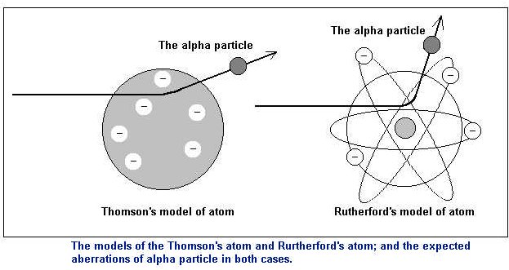

Coulomb potential – electromagnetic interaction

(Repulsion)

“Yukawa” Interaction potential

– screened Coulomb potential

(Attraction)

$V_{tot}\left(r\right)= V_{C,21}+V_{Y}$

**g**: Coupling constant

**μ**: Pi meson mass

$=\frac{1}{4πε_{0}}\frac{q^{2}}{r}-\frac{g^{2}}{4π}\frac{1}{r}e^{-μr}$

**r**: Distance between 2 particles

**ε0** ≈ 8.854187817620... × 10−12 F·m−1

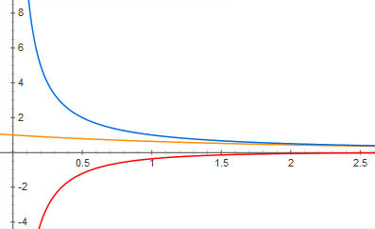

**r (Å)**

**Vtot (eV)**

$$\frac{q^{2}}{4πε_{0}}=\frac{g^{2}}{4π}=μ=1$$

The radii of most nuclei are represented fairly well by empirical relation:

r = r˳A**1/3**

where r˳ is an empirical constant = **1.2 x 10−15 m** and A is the atomic mass number.

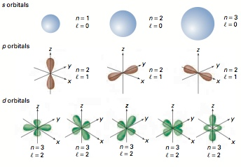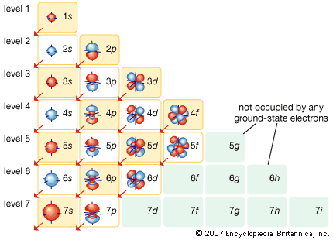

**Quantized energy**

* The state corresponds to the lowest energy state is known as **ground state**. The states with higher energy are known as **excited states** (absorbing extra energy).
* **Radiative transition** -The excited state can return to the ground state by releasing its extra energy via the emission of a photon.

**Pauli’s exclusion principle**

* No two electron can occupy the same state
* For each energy level, the electron can either be spin up or spin down As a result, each energy level can be occupied by no more than two electrons.
* Different states correspond to different average distances from the nucleus.
* Thus in an atom, there is not enough room for all the electrons to occupy states near the nucleus; some are forced into states farther away, having higher energy.

**Robert Milikan**

* All objects may have a charge equal to an integral number of a basic unit of charge
* ***Ntot=Ne***

**Coulumb’s law**

* + represents attraction and $F=(+ve)$ represents repulsion

$k_{e}=\frac{1}{4πε_{0}}$

$ε_{0}= 8.8542 × {10}^{-12} C^{2}/Nm^{2}$

**Electron volts**

$1 eV = 1.6 × {10}^{–19} J$

* Energy gained by an electron after passing through two electrodes with a potential of 1 volt.

**Inter-atomic bonding**

* **Covalent bond** *(refer to hybridization table below)*
* **Ionic bond (Electrovalent)**
* Ionization energy - Energy required to remove an electron from its shell to infinity.
* Electron affinity - Energy released when an electron is added to an atom in gaseous state.
* $E_{P}\left(r\right)=-\frac{e^{2}}{4πε_{0}r}+\frac{b}{r^{9}}$*(refer to graph below)*
  + The first term represents the electrostatic attraction (-ve sign) between two oppositely charged ions (each with charge **e**), separated by a distance **r**.
  + The second term represents the repulsion (+ve sign) between the nuclei and closed shell. The exponent **9** was chosen because it produces the best fit to experimental data. Here **b** is a constant that can be determined via experiment.

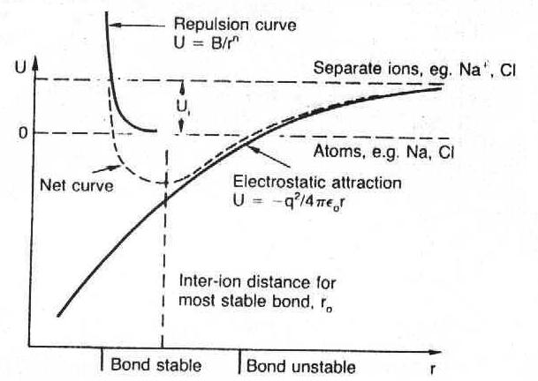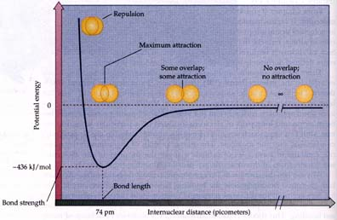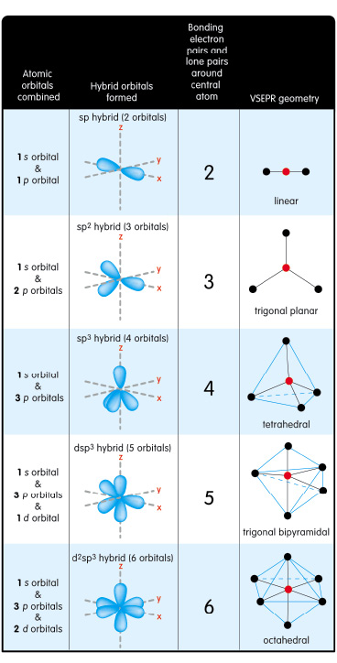

**Inter-molecular forces**

* **Van der Waals force** (Force due to temporary uneven distribution of charges)
* While being electrically neutral, a molecule has a charge distribution with positive and negative centers at different positions in the molecules.
* As a result, the molecules may act as an electric dipole. Because of the dipole electric fields, two molecules can interact such that there is an attractive force between them.
* **Hydrogen Bond** (dipole-dipole attraction force due to dipole moment resulted from uneven distribution of charges as hydrogen atom is bonded to another highly electronegative atom)

**Structure**

* The Structure of all crystals can be described in term of a lattice, with a group of atoms attached to every lattice point.
* The group of atoms is called the basis, when repeated in space it form the crystal structure.
* **Lattice + basis = crystal structure**

|  |  |  |  |  |
| --- | --- | --- | --- | --- |
|  | **SC** | **BCC** | **FCC** | **HCP** |
| **Packing fraction** | 0.52 | 0.68 | 0.74 | 0.74 |

*Memorize!*

**Simple cubic:** (1 sphere per unit)

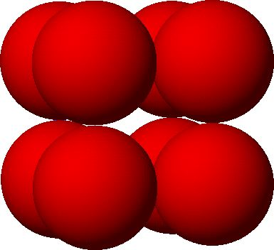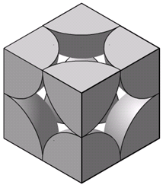

**Body-centered Cubic:** (2 spheres per unit)

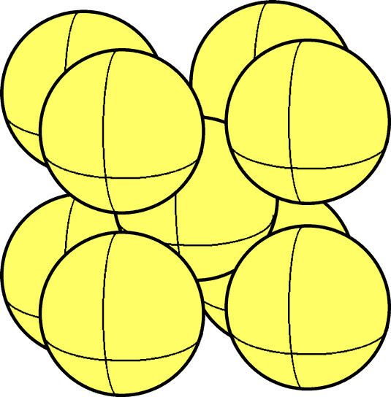 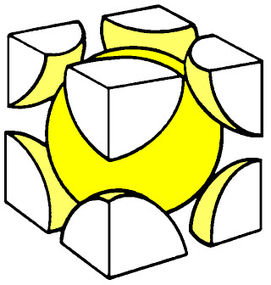 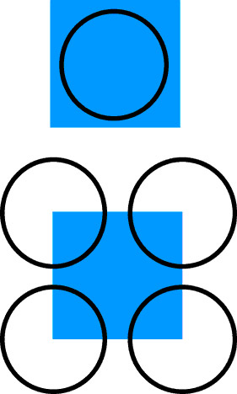

**Cubic-close pack/Face-centered Cubic:** (4 spheres per unit)

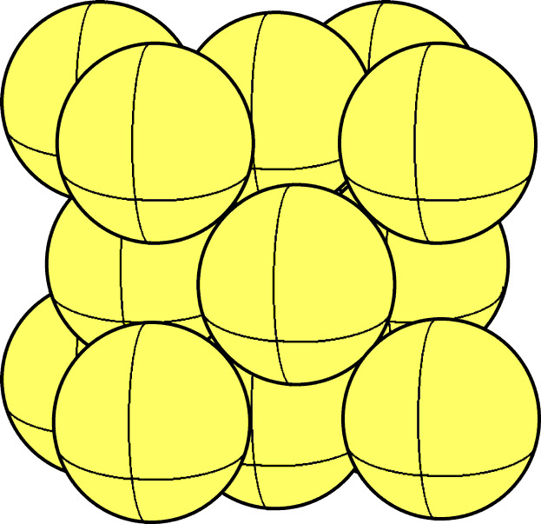 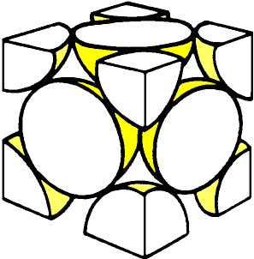 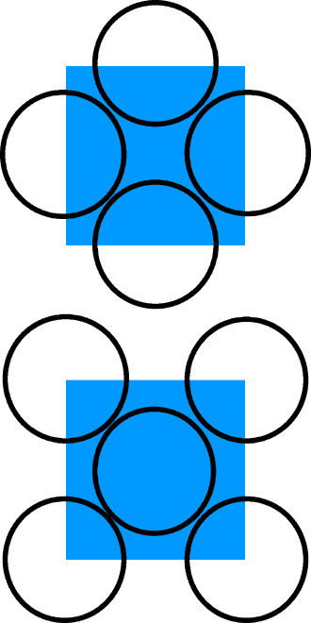

**Hexagonal close pack:**

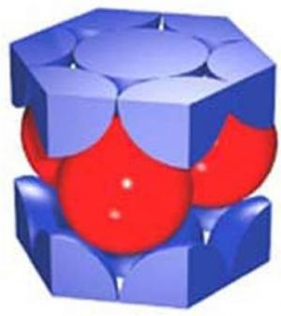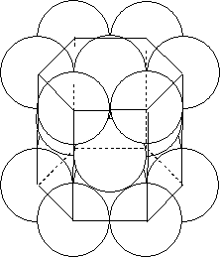 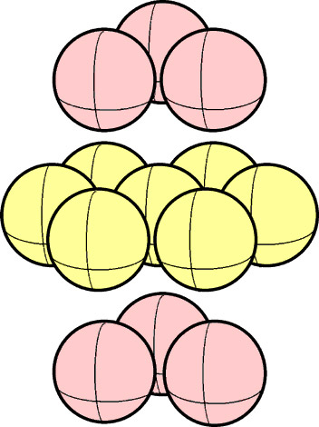 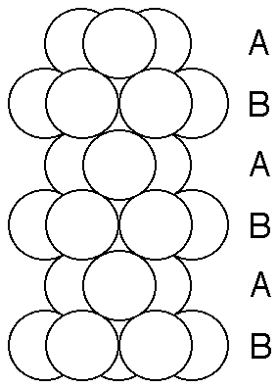

[**Difference between HCP and FCC**](http://www.chem1.com/acad/webtext/states/crystals-cubic.html)

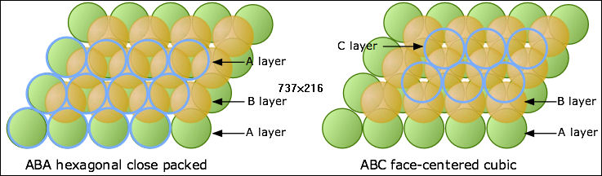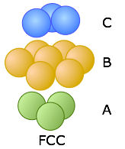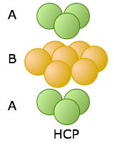

**Packing for atoms of different sizes:**

Packing determined by the larger atoms and the smaller atoms make do with whatever space that is left

**Energy band**

The **electronic band structure** (or simply **band structure**) of a solid describes those ranges of energy, called ***energy bands***, that an electron within the solid may have ("allowed bands"), and ranges of energy called band gaps ("forbidden bands"), which it may not have. **Band theory** models the behavior of electrons in solids by postulating the existence of energy bands. It successfully uses a material's band structure to explain many physical properties of solids, such as electrical resistivity and optical absorption.

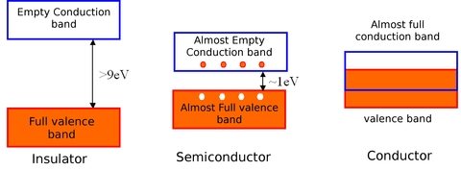

**Electromagnetic spectrum**

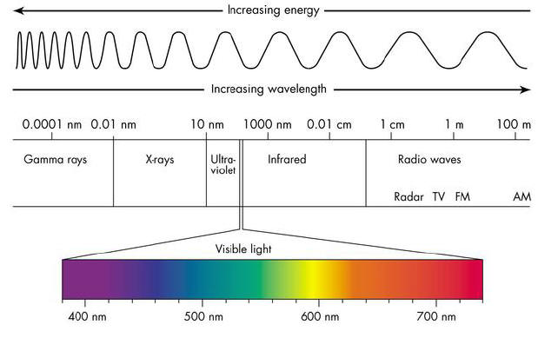

**Blackbody radiation**

* A cavity whose walls are at a certain temperature.
* Atoms composing the walls are emitting electromagnetic (EM) radiation; at the same time they absorb radiation emitted by other atoms of the walls.
* EM radiation occupies the whole cavity.
* At equilibrium, the amount of energy emitted by atoms = amount of energy absorbed.
* Energy density of the EM field is constant.
* A small hole in the cavity allows the EM wave to escape from the cavity and be detected in experiments.

**Stefan’s law:**

In blackbody radiation, the total power (P) of the emitted radiation increases with temperature (T).

$$P=σAeT^{4}$$

* $P$ power (in Watts) radiated from the surface of an object
* Stefan-Boltzmann Constant $σ= 5.670×{10}^{-8 }W/m^{2}K^{4}$
* $A$ Surface area of the object in m2.
* Emissivity of the surface.

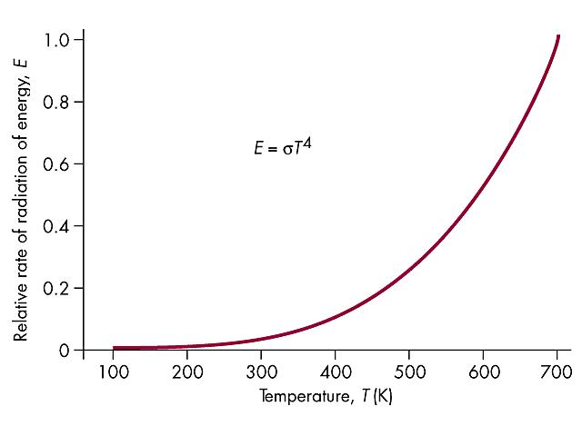

**I (W/m2)**

Blackbody Intensity **I = P/A = T4**

**Wien’s Law:**

The wavelength, $λ_{max}$, at which the monochromatic energy density of blackbody radiation is maximum at a given temperature , **T**, follows a simple relation known as Wien’s Law

$$λ_{max}=\frac{b}{T}$$

Where **b = 2.8978 x 10–3 m.K** (meter kelvins)

**Wien’s approximation:**

$$I\left(λ,T\right)=\frac{2hc^{2}}{λ^{5}}e^{-\frac{hc}{λk_{b}T}}$$

An approximation when $λ$ is small, ( $hf>>KT$ or $h\frac{c}{λ}>>KT$)

Wien’s law is derived from differentiating this approximation to find the $λ$ at which curve is at maximum

**Rayleigh-Jeans law:**

$$I\left(λ,T\right)=\frac{2ck_{b}T}{λ^{4}}$$

* Where $k_{b}$ is the Boltzmann constant.
* Law works well for large wavelengths but
* Rayleigh-Jeans law lead to the ultraviolet catastrophe at short wavelengths

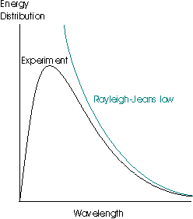

**Planck’s postulate:**

* Cavity Radiation came from atomic oscillators in the cavity walls.
* Energy of an oscillator can have only certain discrete values **En**
* ***En = nhf***
* ***n*** = integer known as quantum number
* ***f*** = frequency of oscillation
* ***h*** is a new fundamental constant of nature known as Planck’s constant h = **6.63 x 10-34 Joules sec**

**Planck’s equation:**

$$I_{p}\left(λ,T\right)=\frac{2hc^{2}}{λ^{5}}\frac{1}{e^{\left(\frac{hc}{λk_{b}T}\right)}-1}$$

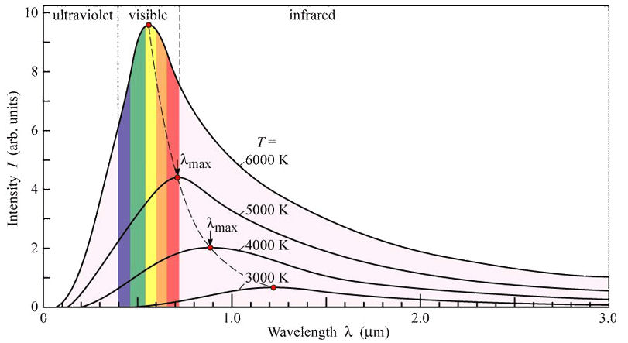

|  |  |  |  |
| --- | --- | --- | --- |
| **Body** | ***Temperature (K)*** | $$λ_{max} (m)$$ | **EM spectrum range** |
| Human | 300 | ~10-6 | Infrared |
| Tungsten Filament | 2000 | ~10-6 | Infrared |
| Sun | 5800 | ~10-7 | Visible light |

**Photoelectric Effect**

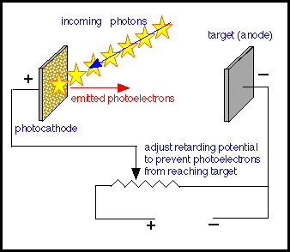

Each photon has energy:

$$E=hf$$

Work function $φ$ is the work done by an electron to overcome the electrostatic forces in order to escape the material surface. If photon does not carry energy more than $φ$, photoemission would not take place. Thus a minimum incident photon frequency is needed:

$$hf_{min}=φ$$

If photon has $hf>φ$ all energy is transferred to electron and the excess energy becomes the initial and maximum kinetic energy of thephotoelectron:

$${KE}_{max}=hf-φ$$

A stopping potential, ***V0***, could thus be reached when there is no current flowing through the circuit. At this point, the maximum kinetic energy of electrons is equal to the electrical potential energy that the electron will lose when travelling under such a field ${KE}_{max}=eV_{0}$. Thus:

$${eV}_{0}=hf-φ$$

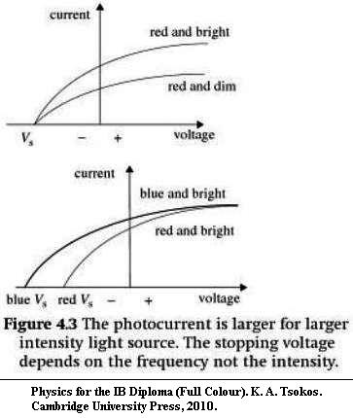 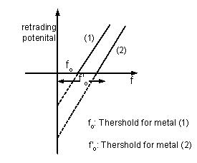

**Wave-Particle Duality**

$$λ_{dB}=\frac{h}{p}$$

* Where is $λ_{dB}$ isthe de Broglie Wavelength
* $p$ Is the momentum of the particle

**Heisenberg Uncertainty Principle**

$$∆x∆p≥\frac{h}{2π}$$

* It is impossible to know simultaneously and with exactness both the position and the momentum of a particle.
* The act of measurement changes the system
* This is not dependent on the precision of instrument used but rather an inherent property of nature
* If we do not determine the position or momentum of a particle, then the particle is in a probabilistic state
* Heisenberg Uncertainty Principle thus implies that we cannot talk about the trajectory of an atomic particle in the sense that we know the exact position and momentum of the particle with time.

**Wave function $Ψ\left(x,t\right)$**

${\left|Ψ\right|}^{2}$ is interpreted as the probability density function that a particle can be found in a particular region in space and at a particular time.

* ${\left|Ψ\right|}^{2}$ sometimes can be independent of time (even though wave function is not) 🡺 probability of finding a particle over a selected region is constant

**Schrodinger's equation:**

* Wave function is determined from the dynamical states of a particle
* The forces acting on a particle determines it’s potential energy which defines the dynamical state of the particle

$$E_{total}=E_{kinetic}+E_{potential}$$

For non-relativistic particles,

$$E=\frac{p^{2}}{2m}+V$$

For 1 dimension (i.e. $Ψ(x)$),

$$EΨ=-\frac{h^{2}}{8π^{2}m}\frac{d^{2}Ψ}{dx^{2}}+VΨ$$

**Particle in 1 dimensional infinite square well (particle in a box)**

From Schrodinger's equation we re-arrange to get, $$\frac{d^{2}Ψ}{dx^{2}}=-k^{2}Ψ, k^{2}=\frac{8π^{2}mE}{h^{2}}$$

We can ascertain that the following wave function fits the above description,

$$Ψ\left(x\right)=Asin\left(ωx\right), ω=n\frac{π}{L}$$

* Sine function because at $x=0$ and $x=l$, $Ψ\left(x\right)=0$

$n∈z^{+} (i.e. n=1,2,3…)$

**To obtain $ω$:**

$$\frac{dΨ\left(x\right)}{dx}=Aωcos\left(ωx\right)$$

$$\frac{d^{2}Ψ\left(x\right)}{dx^{2}}=-Aω^{2}sin\left(ωx\right)$$

Substitute derivatives into Schrodinger relation obtained earlier,

$$-Aω^{2}sin\left(ωx\right)=-k^{2}[Asin\left(ωx\right)]$$

Thus,

$$k=ω= n\frac{π}{L}$$

**To obtain A:**

Probability density function normalization for ${\left|Ψ\right|}^{2}$ must be equal to 1,

$$\int_{0}^{L}{{\left|Ψ_{n}(x)\right|}^{2}dx=1}$$

Evaluating, we obtain,

$$A=\sqrt{\frac{2}{L}}$$

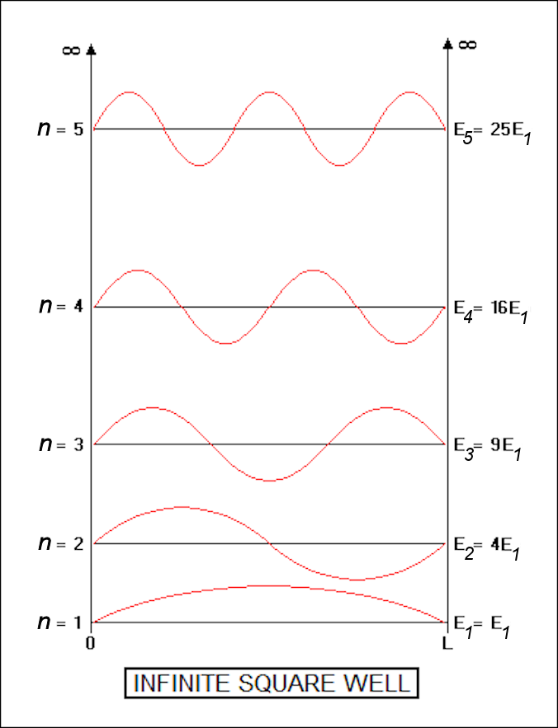**Thus the wave function for the particle is**

$$Ψ_{n}\left(x\right)=\sqrt{\frac{2}{L}}sin\left(\frac{nπ}{L}x\right), n∈z^{+}$$

**Quantization of energy levels:**

We know that,

$$k^{2}=\frac{8π^{2}mE}{h^{2}}$$

Having derived that,

$$k= n\frac{π}{L}$$

Thus equating and rearranging,

$$E_{n}=\frac{n^{2}h^{2}}{8mL^{2}}$$

$$E_{n}=n^{2}E_{1}$$

**Some conclusions:**

* Particle can only attain discrete levels of energy and not any arbitrary continuous value🡺 Energy is quantized
* $n$ is known as quantum number
* Energy levels resembles rungs on a ladder that spread apart farther as it goes higher because $E_{n}=n^{2}E_{1}$
* The quantization of energy is not limited to the infinite square well but also extends to all physical systems in which a particle resides within a finite potential well that confines it to move in a limited region. (Like an electron spinning in an atom or a marble trapped and oscillating in a bowl for instance)

**Schrodinger's equation for an electron in a Hydrogen atom**

Energy of the electron is given by:

$$E_{n}=-\frac{m_{e}e^{4}}{8n^{2}{ε_{0}}^{2}h^{2}}$$

Where $m_{e}$ is the electron rest mass and $ε_{0}$ is the permittivity of free space

$$E_{1}=-13.6eV$$

Thus,

$$E_{n}=\frac{-13.6eV}{n^{2}}$$

* Note that $13.6eV$ is also known as the ionization energy for hydrogen atom as it corresponds to the energy required to bring the electron to infinity
* Energy levels gets closer as $n$ increases

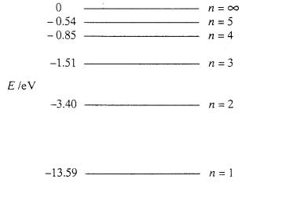

**Schrodinger's equation for a single electron in any given atom**

Energy of the electron is given by:

$$E_{n}=-\frac{m_{e}e^{4}Z^{2}}{8n^{2}{ε_{0}}^{2}h^{2}}$$

Or in alternate fashion,

$$E_{n}=-\frac{RhcZ^{2}}{n^{2}}$$

* Rydberg’s constant $R=1.0974×{10}^{7}m^{-1}$
* Proton number **P**
* Speed of light $c=29979248 ms^{-1}$

**Emission spectrum for hydrogen**

$$\frac{1}{λ}=R(\frac{1}{{n_{f}}^{2}}-\frac{1}{{n_{i}}^{2}})$$

Where $n_{f}$, $n_{i}$ refers to final energy level and initial energy levels respectively

**Atomic spectra**

Different objects have different characteristic emission and absorption line spectrums that correspond to all the possible energy transitions for the electrons in the system.

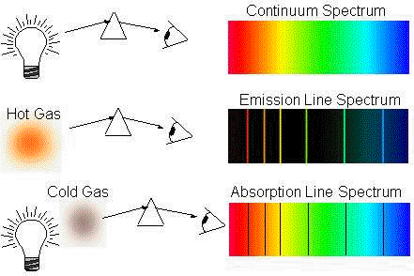

**Resistivity**

$$ρ=\frac{E}{J}, σ=\frac{1}{ρ}$$

* $ρ$ is the resistivity of the conductor material ($Ω⋅m$)
* $σ$ is the conductivity of the conductor material ($Ω^{-1}⋅m^{-1}$)
* $E$ is the magnitude of the electric field ($V⋅m^{-1}$)
* $J$ is the magnitude of the current density ($A⋅m^{-2}$)
* $E and J$ are inside the conductor
$$R=ρ\frac{l}{A}$$

* $R$ is the electrical resistance of a uniform specimen of the material ($Ω$)
* $l$ is the length of the piece of material ($m$)
* $A$ is the cross-sectional area of the specimen ($m^{2}$).

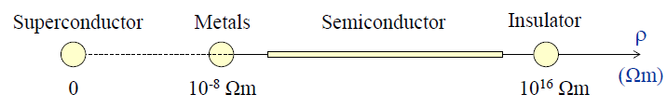

Note: direction of electric field describes the movement direction of a positive charge under it. Thus electrons are influenced to move in the opposite direction.

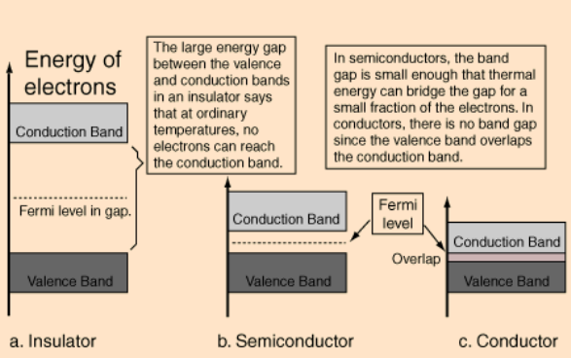**Band Theory**

* When atoms comes close to form crystal structures, discrete energy levels for electrons are replaced by continuous energy bands
* The **Fermi level** is a hypothetical level of potential energy for an electron inside a crystalline solid.
* At conduction band, electrons travel from region of lower potential to a region of higher potential.

**Drift Velocity**

* The **drift velocity $V_{d}$** is the average velocity that a particle, such as an electron, attains due to an electric field.

$$I=\frac{dQ}{dt}$$

Current is the rate of flow of charges against time.



$$V_{d}=\frac{I}{nAq}$$

Where $I$ is current, $n$ is the number of charge carriers per unit volume, $A$ is the cross sectional area, $q$ is the charge possessed by a charge carrier.

**Conductors**

* Resistance increases with temperature

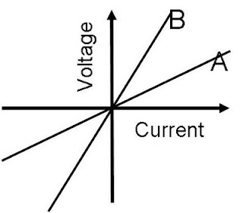 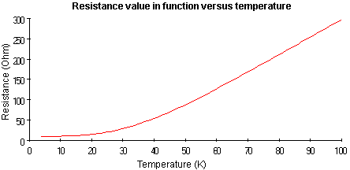

**Semiconductors**

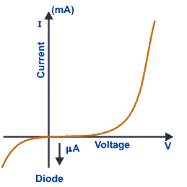

**Intrinsic semiconductors: silicon**

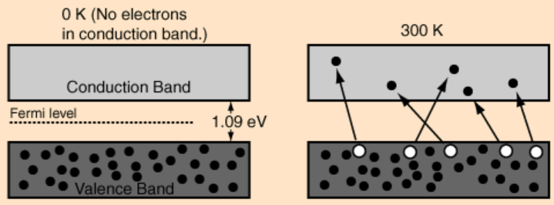

* As temperature increase, more electrons enter the conduction band and participate in the conduction of electricity, lowering resistance
* Resistance **↓** when temperature **↑**.
* Conductance **↑** when temperature **↑**.
* Resistance **↑** when temperature **↓**.
* Conductance **↓**decreases when temperature **↓**.
* Light can be emitted by a semiconductor when conduction electrons recombine with holes.

**Extrinsic Semiconductor: doped Semiconductors**

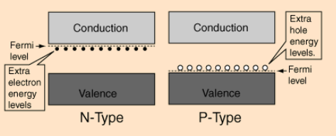

**N-type Semiconductor (**Electrons as majority charge carriers**):**

* 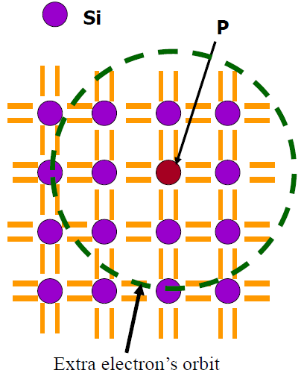Replace one Silicon **Si** (4 valence electrons) atom with a Phosphorus **P** (5 valence electrons) atom.
* Phosphorus is referred to as donor impurities.
* One per million replacement
* P share electrons with 4 Si neighbors and still has 1 unshared electron.
* Filled shells of electrons shield this extra electron such that it is effectively orbiting a single positive charge, just like a hydrogen atom.
* This electron is weakly bound to its parent atom. The radius of this orbit is about 20 times larger than that of an electron in hydrogen. (encompasses many **Si** atoms)
* Easy to make use of this electron for conduction of electricity.

**P-type Semiconductor (**Holes as majority charge carriers**):**

* Replace one Silicon **Si** (4 valence electrons) atom with an Aluminum **Al** (3 valence electrons) atom.
* Aluminum is referred to as acceptor impurities.
* Holes – an electron vacancy.
* Treated as positive charge carriers.
* Holes are attracted towards negative potential

Note: Both types of charge carriers are always present irrespective of the type of doping. I.e. if n-doped then electrons are majority carrier and holes (thermally created via excitation) are minority carriers

**Energy bands**

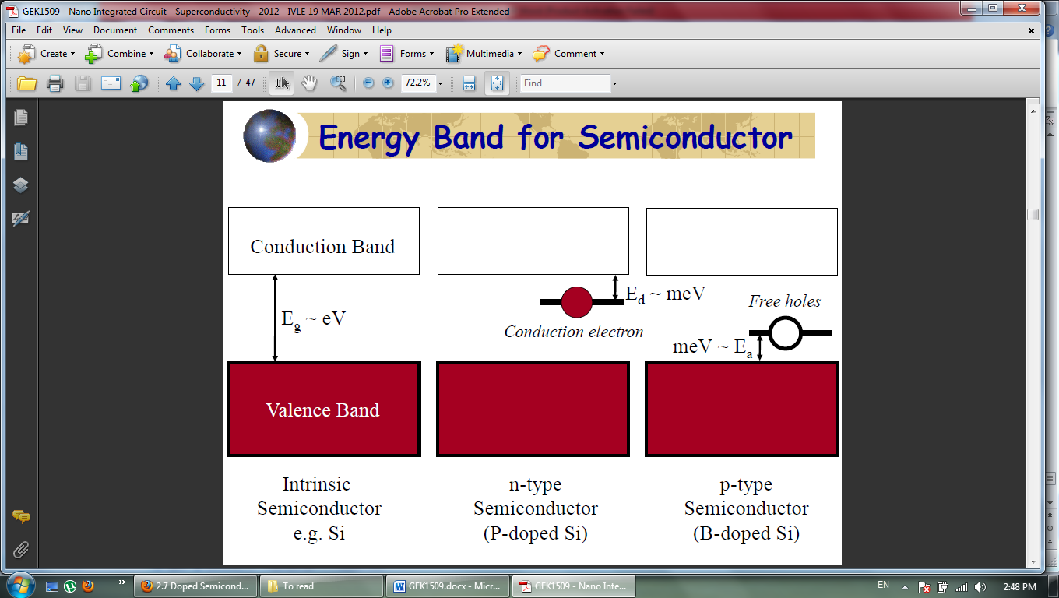

**P-N junctions**

|  |  |
| --- | --- |
| **N-Type**  **(donor impurity: Sulphur)** | **P-Type**  **(acceptor impurity: Boron)** |

For a single crystal of semiconductor silicon (Si), the junction is created by selectively doping donor atoms phosphorus (P) into one half of the sample and acceptor Boron (B) into the other half.

**Formation of depletion zone**

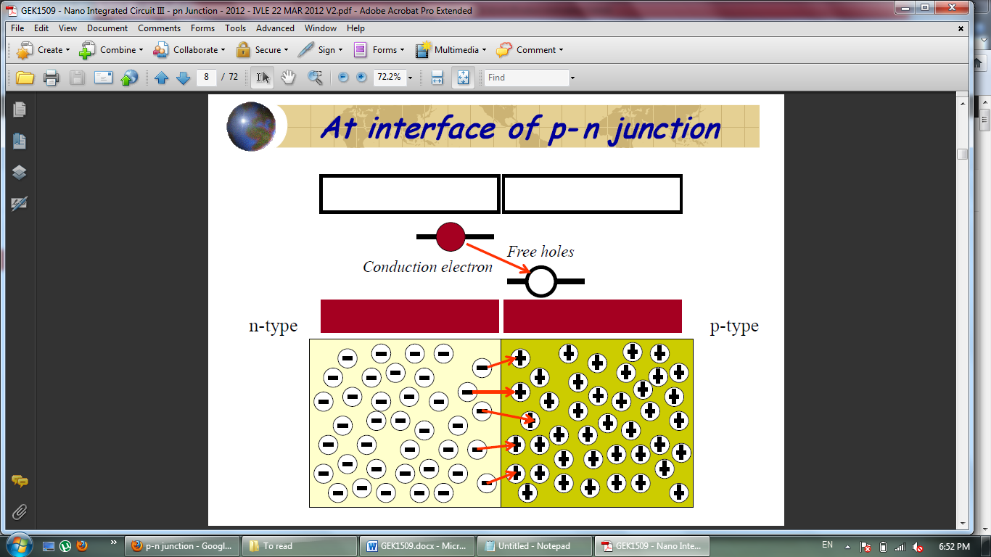 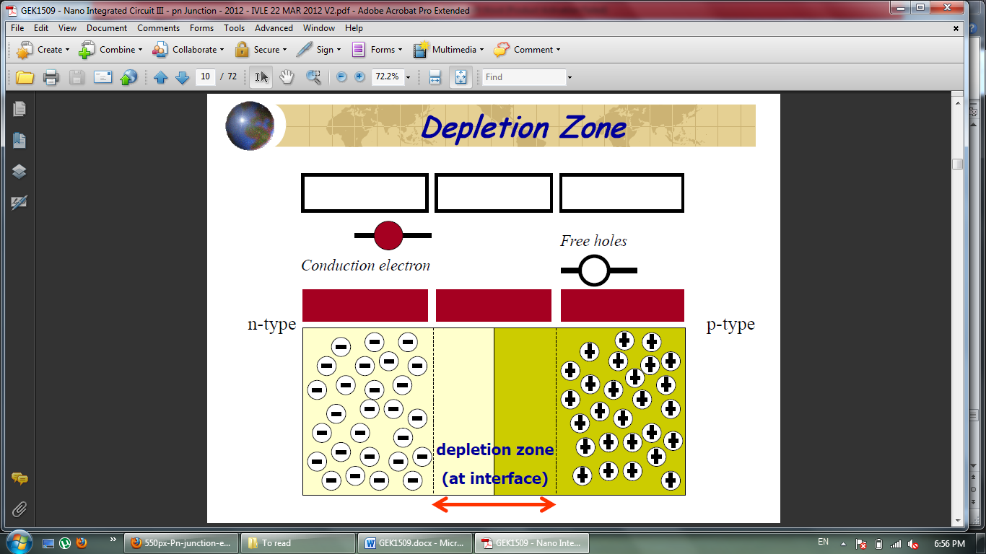

* 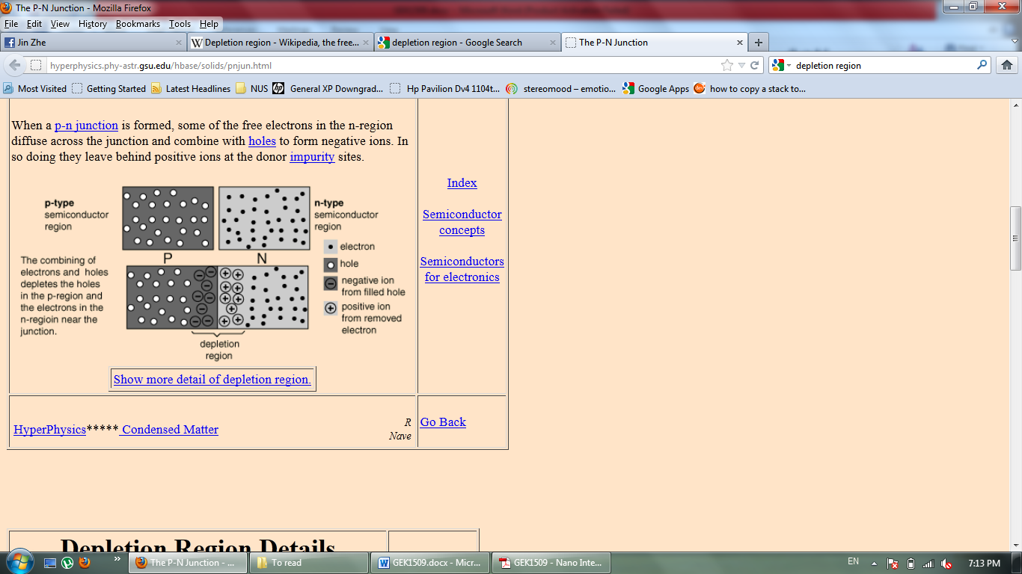Electrons from N-Type are attracted by holes in P-Type, undergoing recombination.
* evetually casue the formation of a depletion zone without mobile carriers (insulating region)
* Any charges wandering into depletion zone will be repelled back by the ions.

**Reverse bias**

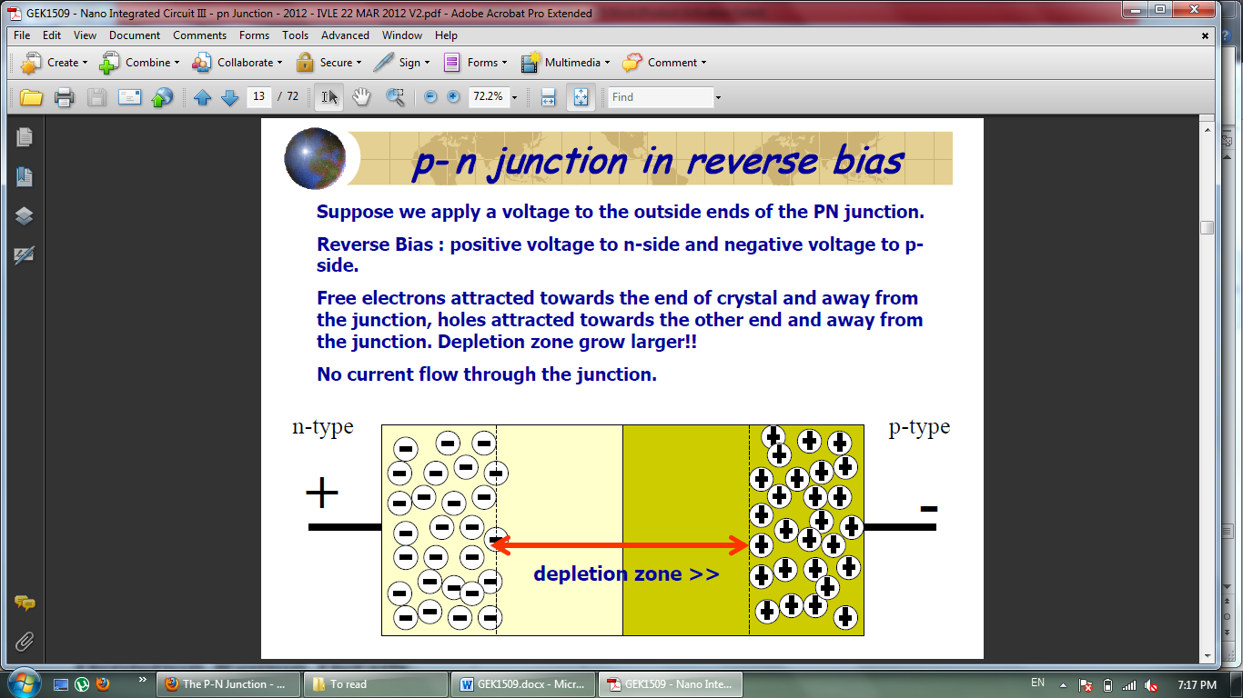

* Positive voltage to n-side and negative voltage to p-side.
* Free electrons attracted towards the positive end of crystal and away from the junction, holes attracted towards the negative end and away from the junction.
* Depletion zone grow larger, insulating region increases.
* No current flow through the junction.

**Forward bias**

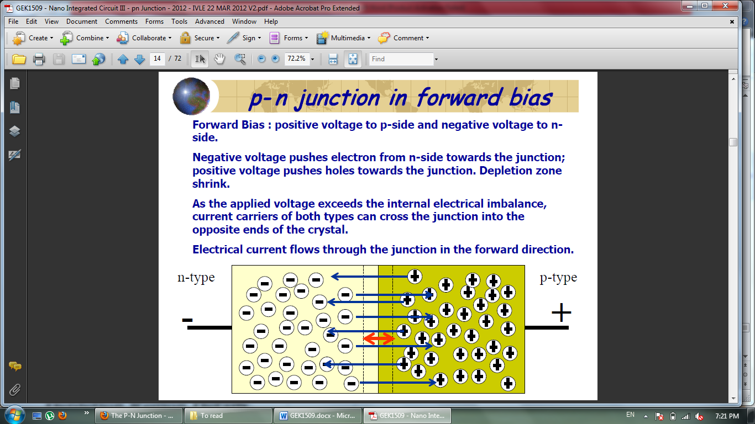

* Positive voltage to p-side and negative voltage to n-side.
* Negative voltage pushes electron from n-side towards the junction; positive voltage pushes holes towards the junction.
* Depletion zone shrink. Insulating region decreases.
* As the applied voltage exceeds the internal electrical imbalance, current carriers of both types can cross the junction into the opposite ends of the crystal.
* Net electrical current flows through the junction in the forward direction, from positive end to negative end.

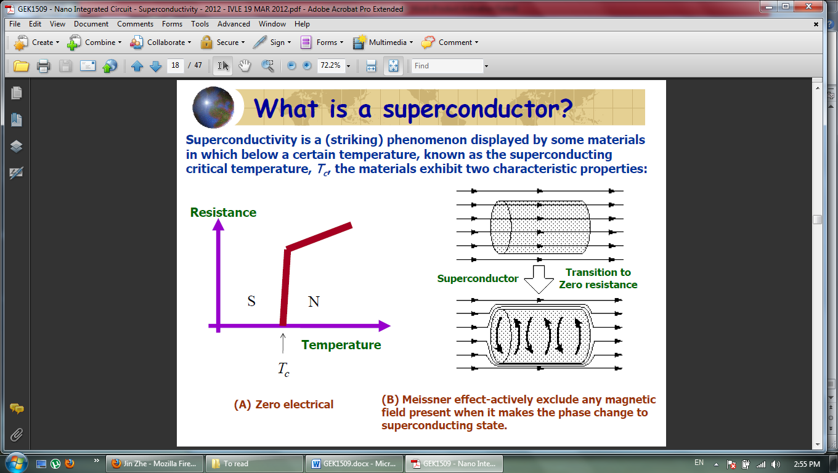**Superconductors**

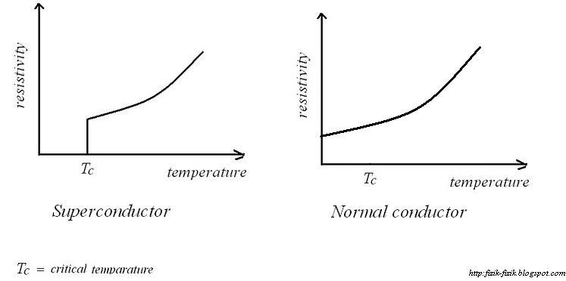

Meissner effect-actively exclude any magnetic field present when it makes the phase change to superconducting state.

**Resistance**: scattering of electrons

* lattice vibration
* electron interaction
* impurity (defect in the solids)



**Cooper pairs**:

Electrons, through the interaction with lattice vibration (phonon), are paired up (cooper pairs) to overcome the scattering caused by lattice vibration.

1. An electron moving through the lattice of positive ions.
2. Due to Columbic interactions, lattice is distorted
3. Second electron coming towards the higher positive density area.
4. Second electron follows the first one and they are bounded (energy is lowest) together.

**Applications**:

* Zero resistance🡺perfect efficiency
* Supercurrent🡺high magnetic field

**Applications of Semiconductors**

**Rectifier diode:**

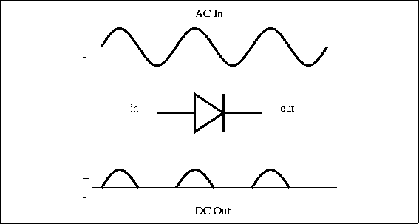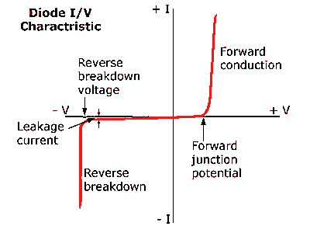

P N

**Light Emitting Diode:**

* At the p-n junction, electron-hole recombination events are concentrated in a narrow region, i.e. at interface, either side of the junction.
* When a forward bias (using a battery) to the junction is applied, this provides a constant source of conduction electrons and holes which move into the region from opposite sides.
* As each pair recombine and emit light, they are replaced by the electrons from battery.
* By varying the applied voltage we can control the rate at which the electrons and hole recombine, thereby controlling the intensity of the light produced.

**Transistors:**

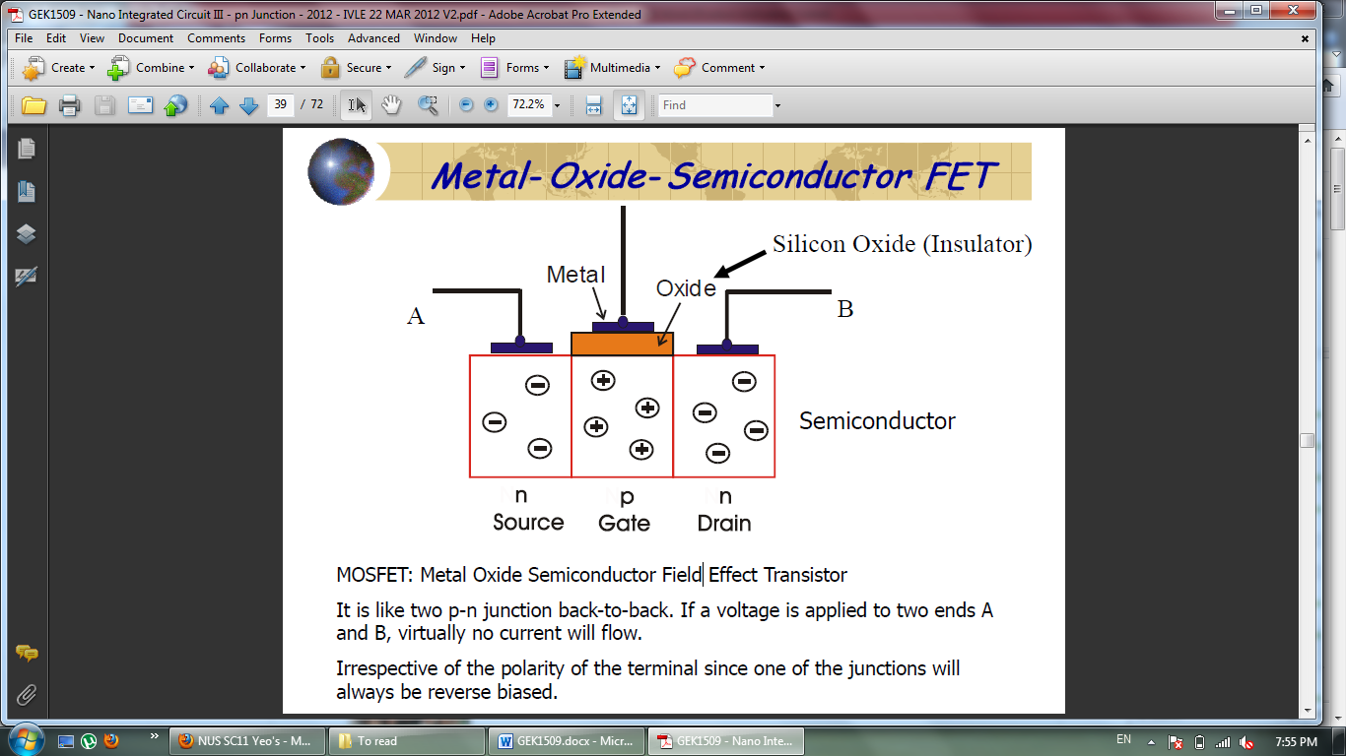

* Source/gate and gate/drain interfaces acts like two p-n junctions back-to-back.
* If a voltage is applied to two ends A or B, virtually no current will flow.
  + This is irrespective of the polarity of the terminal since one of the junctions will always be reverse biased.
* If a positive voltage is applied to the central electrode, current will flow
  + The positive charge on the gate electrode repels the holes at the top surface of the p-type (gate) layer, and pushes them deeper down into the material.
  + A small number of thermally created electrons (known as minority carriers) in the n-type region will be attracted by the positive charge on the gate electrode.
  + They are unlikely to recombine with holes because most of the holes have been pushed away from the surface.
  + By applying a positive voltage to the gate, we have created a narrow channel at the surface. (ON state)
  + The presence of this channel means that electrons can flow freely from one side to the other.
  + Current flowing through the structure can be regulated by applying a small voltage to the gate electrode.

**Integrated circuits:**

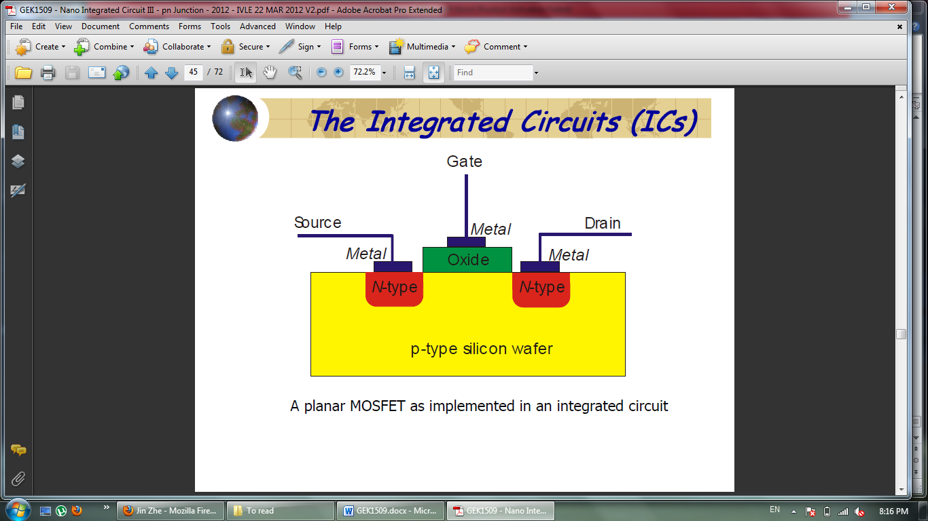

**Nano fabrication by photolithography**

* Photolithography is the conventional method for manufacturing computer chips in bulk.
* A process which selectively remove parts of a thin film or the bulk of a substrate.
* It uses electromagnetic radiation to transfer a geometric pattern from a photomask (template) to a photoresist (light-sensitive chemical) on the substrate (base material).

**Optical lithography by contact or proximity:**

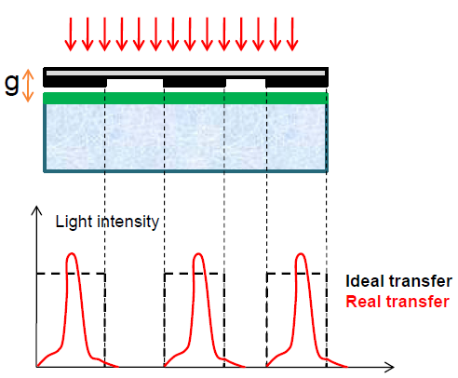

Resolution limited by

* Diffraction; gap minimum=resist thickness
* substrates flatness
* resist damage
* mask damage

**Projection lithography:**

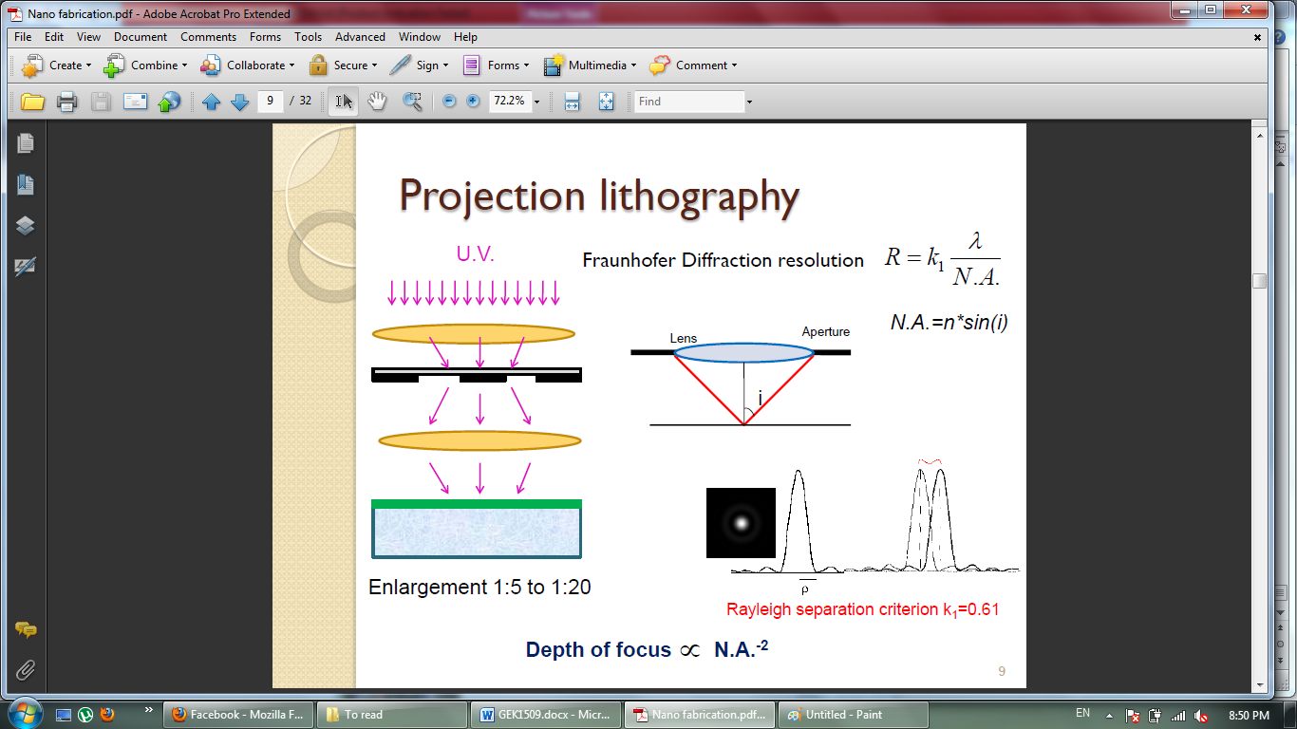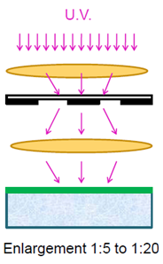

$$N.A. =nsin(i)$$

$$R=k_{1}\frac{λ}{N.A.}$$

Where $R$ is Fraunhofer Diffraction resolution, Rayleigh separation criterion $k_{1}=0.61$.

$$Depth of focus ∝{N.A.}^{-2}$$

**Extreme ultraviolet lithography (EUV):**



The operation needs to be carried out in vacuum

**X-ray Lithography:**

* Mask: Membrane of silicon coated with gold
* Resist: Poly(methyl methacrylate) (PMMA)

Advantages

* Extension to EUV:0.5-2 nm
* Large resolution
* Synchrotron source(storage ring)
* Not absorbed by dirt
* No standing wave formation
* Low absorption by resist: vertical wall construction possible

Problems:

* Cost
* Geometric effects
* Difficulty in mask making

**Electron-beam lithography**



* Produces finer lines
* Not feasible for mass production
* diameter of an electron beam can be as small 0.1 nm

**Nano fabrication by Molding**

**Replica Molding:**

* Pattern is created topographically
* Master pattern transferred in to Polydimethylsiloxane (PDMS) by replica molding
* Liquid precursor solidified against the PDMS mold

**Solvent-Assisted Micromolding (SAMIM):**

*  Uses an elastomeric mold and appropriate solvent

**Micromolding in capillaries (MIMIC):**

* Uses capillarity to fill a series of channels in a PDMS stamp with a low viscosity polymer or ceramic precursor

**Microtransfer molding (μTM):**

* Recessed regions of the mold are filled with prepolymer
* Removing excess prepolymer
* Placing in contact with a rigid substrate and curing the prepolymer

**Nano fabrication by Stamping**

There are two methods for patterning molecules on high resolution surfaces

1. Microcontact Printing (μCP)
2. Electrical Microcontact Printing (e-μCP)

**Microcontact Printing**

Molecules are transferred from PDMS stamp to the substrate by forming covalent bonds

**Electrical Microcontact Printing**

Uses flexible electrode to pattern a thin film of electret-based material by printing and trapping charges (electrect: a permanently polarized dielectric material; its electric field is similar to the magnetic field of a permanent magnet)

**Nanofabrication by Edge Lithography**

Uses topographical changes in the edge of patterns to selectively remove or deposit material at the edges

**Controlled undercutting**:



* Isotropic etching is non-directional removal of material from a substrate via a chemical
* Uses Isotropic etching followed by thin film deposition

Phase shifting Lithography:

* Uses the phenomenon to project "dark or "bright" spots of incident light onto the surface of a photoresist